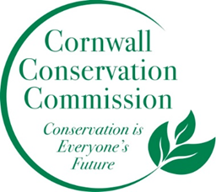Cornwall Conservation Commission
Agenda
Thursday May 21, 2026, 9 am
Zoom
https://us06web.zoom.us/j/81605468726?pwd=OXfj6mhjG376vlztXD2T3R9l8H26df.1
Meeting ID: 816 0546 8726
Passcode: 893246

- Call to order
- Approval of April Meeting Minutes
- Additions to or Approval of Agenda
- Update on adding a final new commissioner

- Voting in a new Treasurer
- Website Updates, Tony and/or Margie
- Review calendar (attached) and discuss upcoming events, find a date for a Town Invasive plant work day
- Invasives Update, Deb, Lisa, Heidi
- Review of Dean's horizontal logo options, Lisa
- List serve, Heidi
- Nature Notes for the Chronicle, June’s
Conservation Commission Desk: The Cornell Bird Lab says, peak migration for our neck of the woods is around mid to late-May and continues through mid-June. To help keep birds safe, turn outdoor lights and draw the curtains to keep light indoors, between 11:00 p.m. to 6:00 a.m.
- Sustainable CT Update, Katie
- Agriculture Update, Robin
- Update on Housatonic Railroad spraying meeting, update on HRC grant application
- Finance: Vote on any upcoming invoices that need payment
New Business
Public Comment
Adjourn

2026 Meeting Schedule:
January 15, 2026
February no meeting
March 19, 2026 - in person at the Library
April 16, 2026, 9am
May 21, 2026, 9am
June 18, 2026, 9am
July 16, 2026, 9am
August 20, 2026, 9am
September 17, 2026, 9am
October 15, 2026, 9am
November 19, 2026 - in person Annual Planning Meeting
December no meeting

