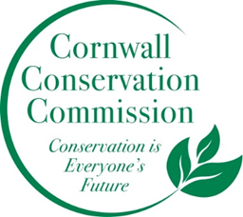Cornwall Conservation Commission
Agenda
Thursday March 19, 2025, 9 am
In person at the Cornwall Library

Meeting and Commission Business
- Call to order
- Approval of January Meeting Minutes
- Additions to or Approval of Agenda

- Introduction of Ellie Appleseed (newly appointed commissioner) and Michele Paladino (soon to be appointed commissioner). Please feel empowered to tell us a little about who you are and what you’re interested in vis a vis the Commission. We can take a bit of time here to chat.
- Cornwall Foundation Grant, Lisa Keskinen
- Website Update, Tony
- Selectman’s letter, Robin
- Past and Coming Events:
  - Dark Sky C, held at Audubon, can Deb Report? Do we want to have a second event with them at our library?
  - Vernal Pool lecture, Joe Markow, March 27th?
  - Native Plant Sale, Mary 23rd 11-11:30, Michele
  - Watershed Event, Michael Dietz, May 30th, 11am Cornwall Library
  - Beaver event, conversation postponed
- Sustainable CT Update, Katie
- Agriculture Update, Robin
- Financial Update, Heidi
New Business
Public Comment
Adjourn

2026 Meeting Schedule:
January 15, 2026
March 19, 2026 - in person at the Library
April 16, 2026
May 21, 2026
June 18, 2026
July 16, 2026
August 20, 2026
September 17, 2026
October 15, 2026
November 19, 2026 - in person Annual Planning Meeting

