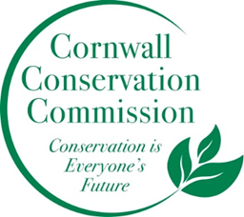Cornwall Conservation Commission
Agenda
Thursday January 15, 2025, 9 am
Join Zoom Meeting
https://us06web.zoom.us/j/81605468726?pwd=OXfj6mhjG376vlztXD2T3R9l8H26df.1
Meeting ID: 816 0546 8726
Passcode: 893246
Meeting and Commission Business
- Call to order
- Approval of Agenda
- Approval of December Meeting Minutes
Section #1 Items near completion or recently completed as reported upon by area leaders
Section #2 Education and Outreach
  - See below
Section #3 Active Ongoing Projects Program Monitoring, are reviewed by Committee Leads
- The bulk of the meeting should
  - Review and discuss the proposed calendar Discussion of possible Lights Out Event, Craig; Beaver Event Diane and Sandy Carlson, Watershed Event, Michael Dietz; , Author, Michelle Nijuis Event
  - Review the annual goals from our December meeting, additions, deletions, etc.
- HRC Grant (if there is an update)
- Agriculture, Robin (if you have an update)
- Sustainable CT, Katie (if you have an update)
- Invasives, Lisa, Heidi Deb (if we have an update)

New Business
Public Comment
Adjourn

2026 Meeting Schedule:
January 15, 2026
March 19, 2026 - in person at the Library
April 16, 2026
May 21, 2026
June 18, 2026
July 16, 2026
August 20, 2026
September 17, 2026
October 15, 2026
November 19, 2026 - in person Annual Planning Meeting

