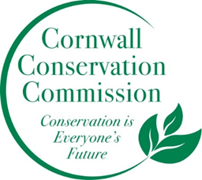
Agenda
Special Meeting of the Cornwall Conservation Commission
November 3, 2025, 10AM
The Cornwall Library

The Cornwall Conservation Commission will hold a discussion of the subdivision regulations and their intersection with Conservation Open Space.

