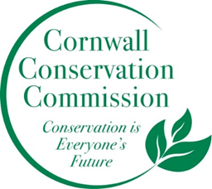
Agenda
Special Meeting of the Cornwall Conservation Commission
December 11th, 2025, 11AM
107 Cream Hill Road

The Cornwall Conservation Commission will hold a planning meeting to discuss strategies and priority work for calendar year 2026.

