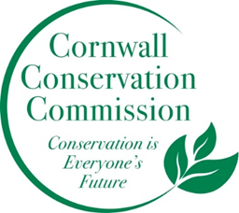Cornwall Conservation Commission
Agenda
Thursday September 18, 2025, 9 am
Join Zoom Meeting
https://us06web.zoom.us/j/81605468726?pwd=OXfj6mhjG376vlztXD2T3R9l8H26df.1
Meeting ID: 816 0546 8726
Passcode: 893246
AGENDA
Meeting and Commission Business
- Call to order
- Approval of Agenda
- Approval of August Minutes
Section #1 Items near completion or recently completed as reported upon by area leaders
Ag Fair - thoughts on this year’s ag fair
Section #2 Education and Outreach
  - Invasives, Lisa
Section #3 Active Ongoing Projects Program Monitoring, are reviewed by Committee Leads
- Steep Slope/Ridgeline - A request from P&Z
- Agriculture, Robin
- Sustainable CT Updates, Katie & Tony
- Composting, Katie Deb Heidi
- Invasives
  - Invasive Grant, Deb, Heidi
    - Meeting for the Grant, CTDEEP;,US Army Corps of Engineers, EPA, US Fish and Wildlife Service.Natural Resource Conservation Service, NOAA Fisherie, And additional PAC members that represent various NGOs
- Health and Environment, Brad
- Lake Task Force, Heidi
- Website updates, Margie
- November planning meeting
New Business
Business on hold or recently completed
Public Comment
Adjourn
Next Meeting Dates, all zoom at 9am, except November:
October 16 , November 20 – In person, planning meeting, No meeting in December

