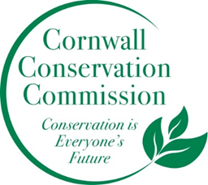Cornwall Conservation Commission
Agenda
Thursday July 17, 2025, 9 am
Join Zoom Meeting
https://us06web.zoom.us/j/81605468726?pwd=OXfj6mhjG376vlztXD2T3R9l8H26df.1
Meeting ID: 816 0546 8726
Passcode: 893246

AGENDA
Meeting and Commission Business
- Call to order
- Approval of Agenda
Section #1 Items near completion or recently completed as reported upon by area leaders
Section #2 Education and Outreach
- Invasives, anyone who has an update
- Foote Field, anyone who has an update
- Ag Fair, Katie
Section #3 Active Ongoing Projects Program Monitoring, are reviewed by Committee Leads
- Agriculture, Robin
- Sustainable CT Updates, Katie & Tony
- Composting, Katie Deb Heidi
- Health and Environment, Brad
- Lake Task Force, Heidi
- Website updates, Margie
- November planning meeting
Work currently on hold, recently completed or not timely
- Steep Slope - Ridgeline
New Business
Public Comment
Adjourn

Next Meeting Dates, all zoom at 9am, except November:
August 21, September 18, October 16 , November 20 – In person, planning meeting

Recap of our Annual Objectives from the May Planning Meeting
What do we want to do more of or what do we want to do this coming year
- Outreach in new ways. Can we do an invasive of the month with a poster? Post it at the library?
- Fill our open seats - blurb in the BoS monthly newsletter and Chronicle
- More information photos etc. on the website - a more robust website
- A powerpoint show running at the Ag Fair
- Better stronger connection to the BoS
- Continue the invasive mapping
- More letting our voice be heard as a small town.
- More composting - either on private property or coordinating with town. TBD.
- Turn the Invasive Policy into an Invasive Action Plan

