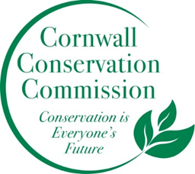Cornwall Conservation Commission
Agenda
Thursday, May 15, 2025, 9 am
Join Zoom Meeting
https://us06web.zoom.us/j/81605468726?pwd=OXfj6mhjG376vlztXD2T3R9l8H26df.1

Meeting ID: 816 0546 8726
Passcode: 893246

AGENDA
Meeting and Commission Business
- Call to order
- Approval of Agenda
- Approval of April Minutes
- Financial Update, Heidi
Section #1 Items near completion or recently completed as reported upon by area leaders
Section #2 Education and Outreach
- Invasives, Lisa +
Section #3 Program Monitoring, active ongoing projects are reviewed by Committee Leads
- Website updates, Margie
- Agriculture, Robin Affordable Housing and Conservation Intersection, Heidi
- Sustainable CT Updates, Katie & Tony?
- Composting, Katie Deb Heidi
- Health and Environment, Brad
- Lake Task Force, Heidi
Work currently on hold, recently completed or not timely

- Steep Slope - Ridgeline
New Business
Public Comment
Adjourn

Next Meeting Dates, all zoom at 9am, except November:
May 15 (maybe be changed to a special meeting) , June 18 (Wednesday so as not to conflict with Juneteenth), July 17, August 21, September 18, October 16 , November 20 – In person

Recap of our Annual Objectives from the May Planning MeetingWhat do we want to do more of or what do we want to do this coming year
- Outreach in new ways. Can we do an invasive of the month with a poster? Post it at the library?
- Fill our open seats - blurb in the BoS monthly newsletter and Chronicle
- More information photos etc. on the website - a more robust website
- A powerpoint show running at the Ag Fair
- Better stronger connection to the BoS
- Continue the invasive mapping
- More letting our voice be heard as a small town.
- More composting - either on private property or coordinating with town. TBD.
- Turn the Invasive Policy into an Invasive Action Plan

