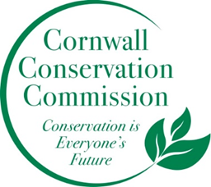Cornwall Conservation Commission
Agenda
Thursday, January 16, 2025, 9 am
Zoom: https://us06web.zoom.us/j/81096866796?pwd=EX8GbOdVPgP7cV3bJQYbV8YxfFRUBw.1

AGENDA
Meeting and Commission Business
- Call to order , Welcome Dr. Bradford Harding, new Commissioner
- Approval of Agenda
- Approval of November minutes
- Budget Discussion
Section #1 Items near completion or recently completed as reported upon by area leaders
Section #2 Education and Outreach
- Invasive Inserts, Lisa
Section #3 Program Monitoring, active ongoing projects are reviewed by Committee Leads
- Sustainable CT Updates, Katie
- Website updates, Margie
- Composting
- Steep Slope - Ridgeline
- Agriculture, Robin
- Affordable Housing and Conservation Intersection,
Work currently on hold, recently completed or not timely
- Approval of 2025 meeting dates
- Lake Task Force

New Business
Public Comment
Adjourn
Next Meeting Dates:
March 20 – In person , April 17 zoom, May 15 zoom, June 18 zoom

Recap of our Annual Objectives from the May Planning MeetingWhat do we want to do more of or what do we want to do this coming year
- Outreach in new ways. Can we do an invasive of the month with a poster? Post it at the library?
- Fill our open seats - blurb in the BoS monthly newsletter and Chronicle
- More information photos etc. on the website - a more robust website
- A powerpoint show running at the Ag Fair
- Better stronger connection to the BoS
- Continue the invasive mapping
- More letting our voice be heard as a small town.
- More composting - either on private property or coordinating with town. TBD.
- Turn the Invasive Policy into an Invasive Action Plan

