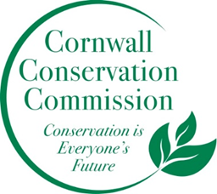Cornwall Conservation Commission
Agenda
Thursday, October 17, 2024, 9 am
Zoom:
Location: Zoom
https://us06web.zoom.us/j/87356386114?pwd=RktKSnZleG5KWC90Tzc1M1h5bm1Zdz09
Passcode: 351100

AGENDA
Meeting and Commission Business
- Call to order, welcome new commissioners
- Approval of Agenda
- Approval of July minutes
Section #1 Items near completion or recently completed as reported upon by the leaders of those areas
- Ag Fair, Katie
Section #2 Education and Outreach
- EDC’s work and intersection with the Commission, Katie
- Composting
Section #3 Program Monitoring, active ongoing projects are reviewed by Committee Leads
- Town Invasive Report Update
  - Invasive work Deb
  - Invasive of the month posters, Heidi
  - Mapping, Lisa Deb Heidi
- Sustainable Land Use Development Presentation
  - Ridgeline protection?
- Website updates
  - Invasive report
  - Invasive Map
  - Lake Presentation pages
- Reminder of upcoming meetings: October 17, November 21 – In person
  - How do we want to use the November in person meeting?
Work currently on hold or recently completed
- Town Resilience Plan
New Business
Public Comment
Adjourn

Recap of our Annual Planning Meeting Objectives
What do we want to do more of or what do we want to do this coming year
- Outreach in new ways. Can we do an invasive of the month with a poster? Post it at the library?
- Fill our open seats - blurb in the BoS monthly newsletter and Chronicle
- More information photos etc. on the website - a more robust website
- A powerpoint show running at the Ag Fair
- Better stronger connection to the BoS
- Finish the invasive mapping
- More letting our voice be heard as a small town.
- More composting - either on private property or coordinating with town. TBD.
- Turn the Invasive Policy into an Invasive Action Plan

