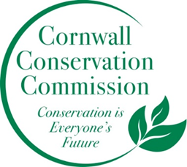
Cornwall Conservation Commission
Agenda
Tuesday, August 20, 2024, 10 am
Zoom:
https://us06web.zoom.us/j/87464468954?pwd=dEtrVmd5Tm1OVjNRZTJJaW5wZUJOUT09
Meeting ID: 874 6446 8954
Passcode: 785708

AGENDA
Meeting and Commission Business
- Call to order. Welcome potential new members
- Approval of Agenda
- Approval of June minutes
Section #1 Items near completion or recently completed as reported upon by the leaders of those areas
- Lake Task Force
  - Milfoil mapping -
  - Lake water testing
Section #2 Education and Outreach
- Read Katie’s statement on Sustainable
- Composting
- Ag Fair
Section #3 Program Monitoring, active ongoing projects are reviewed by Committee Leads
- Town Invasive Report Update
  - Invasive of the month posters
    - August? September? Chronicle?
  - Mapping and moving toward an action plan
- Sustainable Land Use Development Presentation
  - Ridgeline protection?
- Website updates
  - Invasive report
  - Invasive Map
  - Lake Presentation pages
Work currently on hold or recently completed
- Town Resilience Plan
- Herbicide Working Group
New Business
Public Comment
Adjourn

Upcoming meetings for remainder of calendar year: August 15, September 19 (conflict), October 17, November 21 – In person

A reminder of what we said we wanted to do more of this year…
What do we want to do more of or what do we want to do this coming year
- Outreach in new ways. Can we do an invasive of the month with a poster? Post it at the library?
- We want to fill our open seats - blurb in the BoS monthly newsletter and Chronicle
- More information photos etc. on the website - a more robust website
- We want a powerpoint show running at the Ag Fair
- Better stronger connection to the BoS
- Finish the invasive mapping
- More letting our voice be heard as a small town.
- More composting - either on private property or coordinating with town. TBD.
- Turn the Invasive Policy into an Invasive Action Plan

