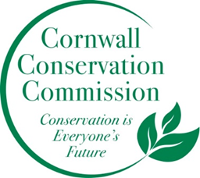
Cornwall Conservation Commission
Agenda
Thursday, November 16, 2023, 9 am
The Cornwall Library (to be confirmed)
AGENDA
- Call to order
- Approval of agenda
- Approval of August and September minutes

Section #1 A discussion of Items near completion or recently completed as reported upon by the captains of those subjects

Section #2 Education, Outreach and Annual Plan
- Sustainable CT- CCS and EDC reports, Katie
- Extreme weather Resiliency Plan, Heidi
Section #3 Program Monitoring, active ongoing projects are reviewed by Committee Leads
- HMSP, Katie
- Town Invasive Removal, Deb
- Ridgeline regulation Update, Heidi and Deb
- Composting Update
New Business
- Review of the CCC Annual Plan and the 2024 Calendar Meeting Dates

Public Comment

Adjourn

