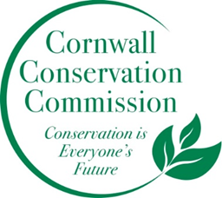
Cornwall Conservation Commission
Agenda
Thursday, January 19, 2023, 9:00 am

Location: Cornwall Library

AGENDA:
- Call to order
- Approval of agenda
- Approval of December minutes

Old Business:
Section #1 A discussion of Items Near Completion as reported upon by the captains of those subjects

Section #2 Education, Outreach and
- Waste/Composting, Nancy and Heidi
- Review and updates as needed to the Calendar of Events

Section #3 Program Monitoring whereby active ongoing projects are reviewed by Committee Leads
- Sustainable CT, Community Resilience Workshop, Katie
- HRRC Herbicide update, Heidi

New Business
The 2023 Budget Sheet from Barbara Herbst
January 30th Planning and Zoning meeting
Watershed Mapping

Public Comment
Work Tabled or Completed
  - NRI - Tabled
    - Noteworthy places
  - Bylaws – completed
  - Website – update has been completed
  - Ridgeline – P&Z reviewing

Adjourn

