TOWN OF CORNWALL

RETURN OF NOTICE

We hereby certify that we will leave a duplicate of the foregoing and attached Warning and Notice for a Town Meeting with Vera Dinneen, Town Clerk,

and further certify that we will set upon the signpost nearest the Office of the Town Clerk and all other places designated by the Town, a copy of said Warning and Notice signed by us as Selectmen,

and further that we will request a copy of said Warning and Notice to be published in the Waterbury Republican,

and further that all of the above acts will be done by us at least five days prior to the holding of said Town Meeting on the 19th day of November, 2021.

SIGNED:

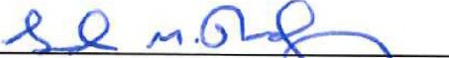
Gordon M. Ridgway, First Selectman

__________________________
Marina Kotchoubey, Selectwoman

Priscilla Pavel, Selectman

Signed this 20th day of October, 2021 in Cornwall, Connecticut.

