LOGO 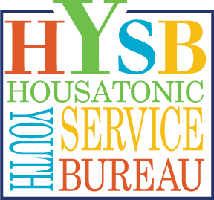 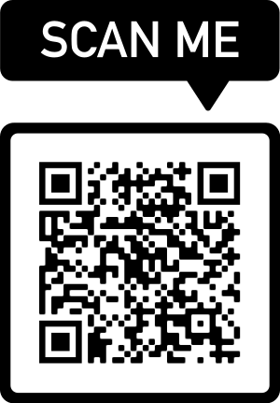

FOR IMMEDIATE RELEASE

Date: 10-14-2021

Contact: Harrison Ungar, Director of Development, Housatonic Youth Service Bureau (HYSB), PO Box 356, 246 Warren Turnpike, Falls Village, CT 06031, HYSB.org, +1 (413) 429-5864, Hungar@HYSBCT.org

HOUSATONIC YOUTH SERVICE BUREAU
LANDS MAJOR SUBSTANCE ABUSE PREVENTION GRANT

(Falls Village, CT) – The Housatonic Youth Service Bureau (HYSB) is thrilled to have received an annual $125,000 federal Drug Free Communities Grant to support the substance abuse prevention work of the Northwest Corner Prevention Network (NCPN), a group of local organizations working together to promote healthy communities. The funds, which will be awarded each year for five years, will allow HYSB and its partner, the McCall Center for Behavioral Health, to expand community outreach and engagement on the critical issues of youth substance abuse and prevention.

“Not only will the grant give HYSB and the McCall Center more capacity to better serve our community,” said HYSB Executive Director Kelly Parker. “The grant positions HYSB to tackle some of the root causes of the anxiety and depression affecting so many of the youth we serve. We are thrilled to be partnering with the McCall Center on this project and to continue the critical work of the NCPN.”
Through the grant, HYSB and the McCall Center will engage young people and adults in a range of community events and presentations focused on preventing substance abuse in Region One, especially in the areas of underage alcohol and marijuana use. The new funding will support the addition of 1.5 full-time employees to perform this important prevention education and training. These services are desperately needed in the Northwest Corner, especially since the advent of COVID-19; the Connecticut State Health Resources and Services Administration for Mental Health has declared the area a “Health Professional Shortage Area.”
The DFC grant will also support essential training for mental health professionals in the area, such as access to a comprehensive training program developed by CADCA, a national nonprofit organization committed to creating drug-free communities; this and other educational opportunities will provide the structure and resources to sustain viable community improvements.
“This grant award allows McCall and HYSB to continue to expand and build upon the incredible youth substance abuse prevention, suicide prevention, and mental health promotion work being done through NCPN,” said Andrew Lyon, Director of Prevention Services at the McCall Center for Behavioral Health. “This funding was awarded because NCPN has demonstrated that it has the people, processes, and collaborative drive necessary to ensure that every dollar is used thoughtfully, efficiently, and effectively.”
The grant could not have come at a more critical time. In the past 30 days, 29% of students reported heightened rates of sadness and symptoms related to depression, which may be compounded by substance abuse. Alcohol use remains the number one concern among youth in the region, with 23% of students reporting alcohol use in the past 30 days—compared to the national average of 18.5%—and one in five students reporting getting into a car during 2021 with a driver who has consumed alcohol.
The grant is a critical piece of a larger strategy to increase NCPN membership, develop youth prevention leadership groups, reduce youth abuse of alcohol, marijuana and other substances, increase youth perceived parental disapproval of youth alcohol use, and increase the perceived risk of substance abuse.
For more information on how to support HYSB or get involved, please visit www.HYSB.org

###

