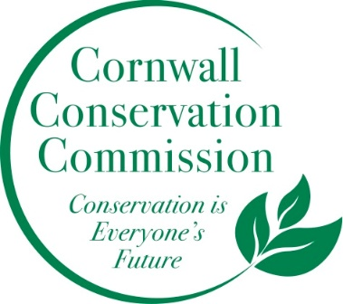

MEETING of the CORNWALL CONSERVATION COMMISSION
Thursday, January 14, 2021 at 10:30 am
To be conducted by a Zoom Meeting:
https://zoom.us/j/92463277711
Meeting ID: 924 6327 7711
One tap mobile
+16465588656,,92463277711# US (New York)
AGENDA:
- Call to order
- Approval of agenda
- Approval of minutes for the meeting of December 10, 2020
- Treasurer’s Report/2020-2021 Budget
Old Business
- Ridgeline Protection Map- Presentation by Stacy Deming of HVA
- Status of Priority Places

- Status of the Natural Resources Inventory
- Cream Hill Lake Task Force status

- Outreach

New Business
- Welcome new commissioner Sean Quinn

Public Comment

Adjourn

